Using the 3G Soft SIM
by Chris Hessing

Installation

The 3G Soft SIM comes with the XSupplicant installation by default. During the installation you simply need to make sure the box is checked so that it is installed and configured properly. When you get to this screen :

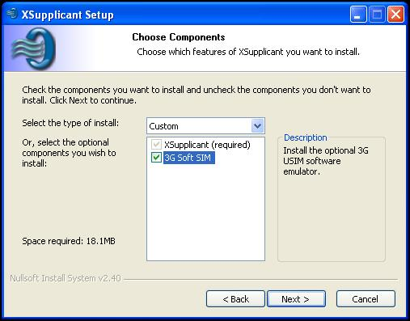

Be sure that you have the option “3G Soft SIM” checked. This will cause the Soft SIM and all related tools to be installed.

Configuring the Soft SIM

Before the Soft SIM can be used, you need to configure it. If you installed the 3G Soft SIM option during the installation, you will have a “3G Soft SIM Manager” program included in the XSupplicant section of the Start menu. Running this program will take you to a window that looks similar to the following :

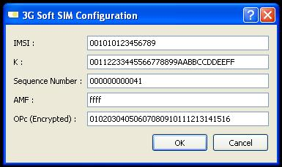
(Note : The fields will be empty if you have not configured the Soft SIM before.)

In this window you should configure the values that you need to be able to talk to your server. Note that the operator code needs to be in its encrypted form in order to work properly.

Configuring the Supplicant to use the Soft SIM

Configuring the supplicant to use the soft SIM is fairly simple. The Soft SIM presents itself to the supplicant as another SIM card reader, so the process used to configure a normal AKA connection is the same if you are using the soft SIM. Open the configuration window by double clicking on the tray icon, selecting the “Tools” option, and then “Configure..”

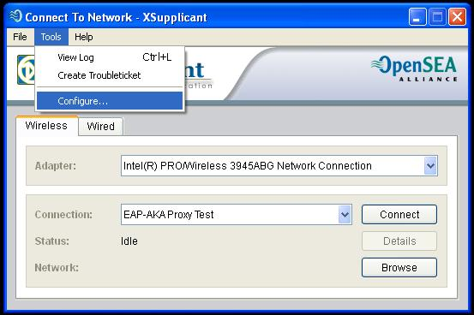
This will cause the configuration window to open :

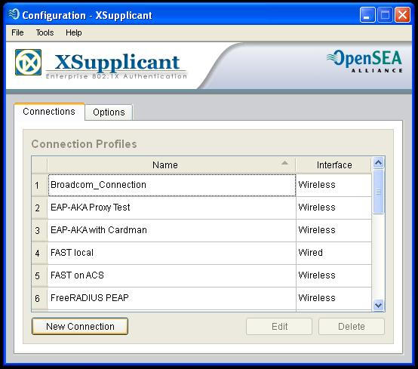
Click on the “New Connection” button to create a new AKA connection. This will bring up the first window in the configuration wizard.

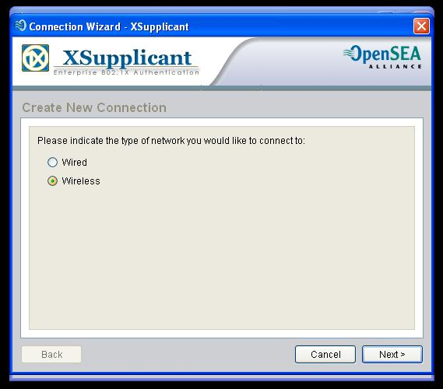
Select the type of connection you are going to use, and click “Next” to bring up the second window in the wizard.

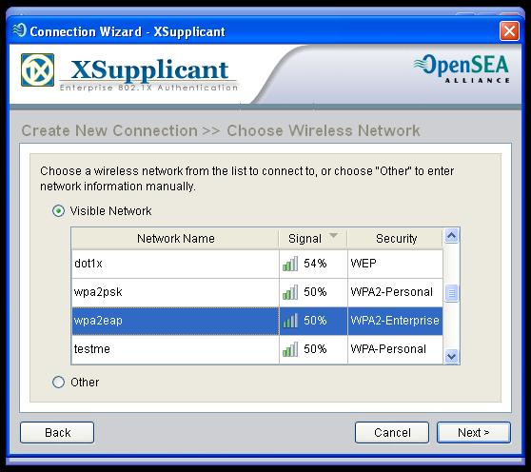
If you are using wireless, select the wireless network that you will use AKA authentication with, and click “Next” to go to the next window in the wizard. (If you are using wired, skip this step.)

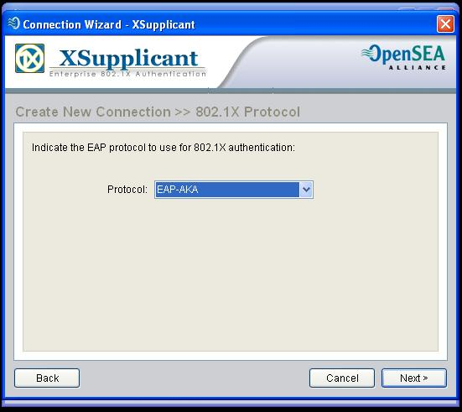
In the Protocol drop-down box, select “EAP-AKA”, then click “Next” to move on to the next window in the wizard.

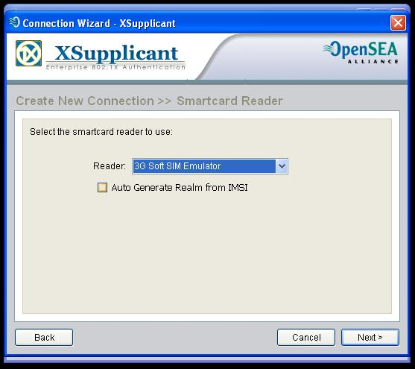
For the smart card reader, select “3G Soft SIM Emulator” to use the emulated smart card you created earlier. If you need to auto generate the realm, you can check the box for that here as well. Once you have done this, click “Next”.

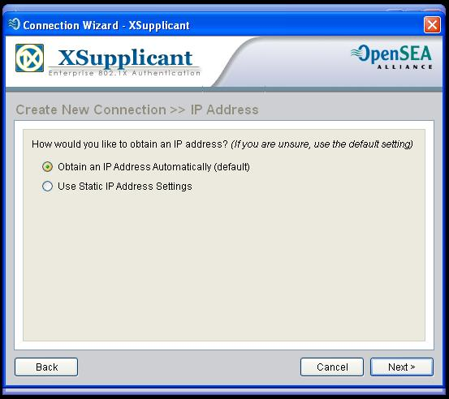
If you are using DHCP, select “Obtain an IP address automatically” here. Then click “Next”.

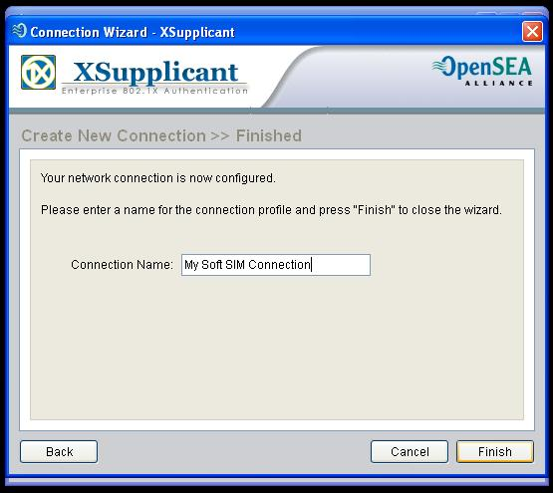

Finally, give your connection a meaningful name, and click Finish.

Using the newly created Connection

Using the connection you just created is done the same way that you would use any other connection. Double click on the tray icon, select the wired or wireless interface you bound this connection to, select the connection from the drop-down box, and click connect. By default, the SoftSIM does not use a PIN. So when you click connect, you should go to “Connected” state without any other dialogs as long as you have configured your AP and RADIUS server correctly.

